- Uploading the data in R studio and viewing it
> data_file <- "/My System/simpledata.csv"
> sample_data <- read.csv(data_file)
> View(sample_data)

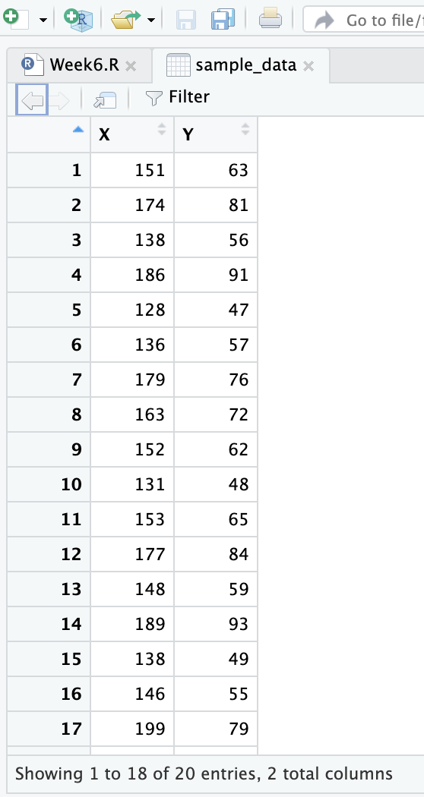
- Summary of the dataset
> summary(sample_data)

Output:

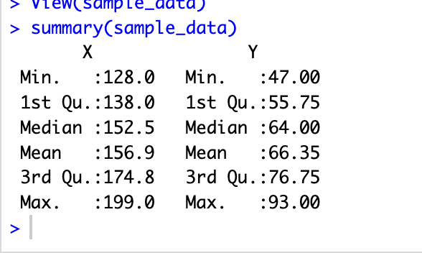

- Structure of the dataset
> str(sample_data)

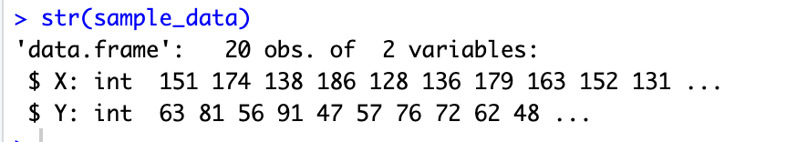
- Scatterplot
> plot(sample_data$X, sample_data$Y, main = "Scatterplot b/w X and Y", xlab = "X", ylab = "Y")

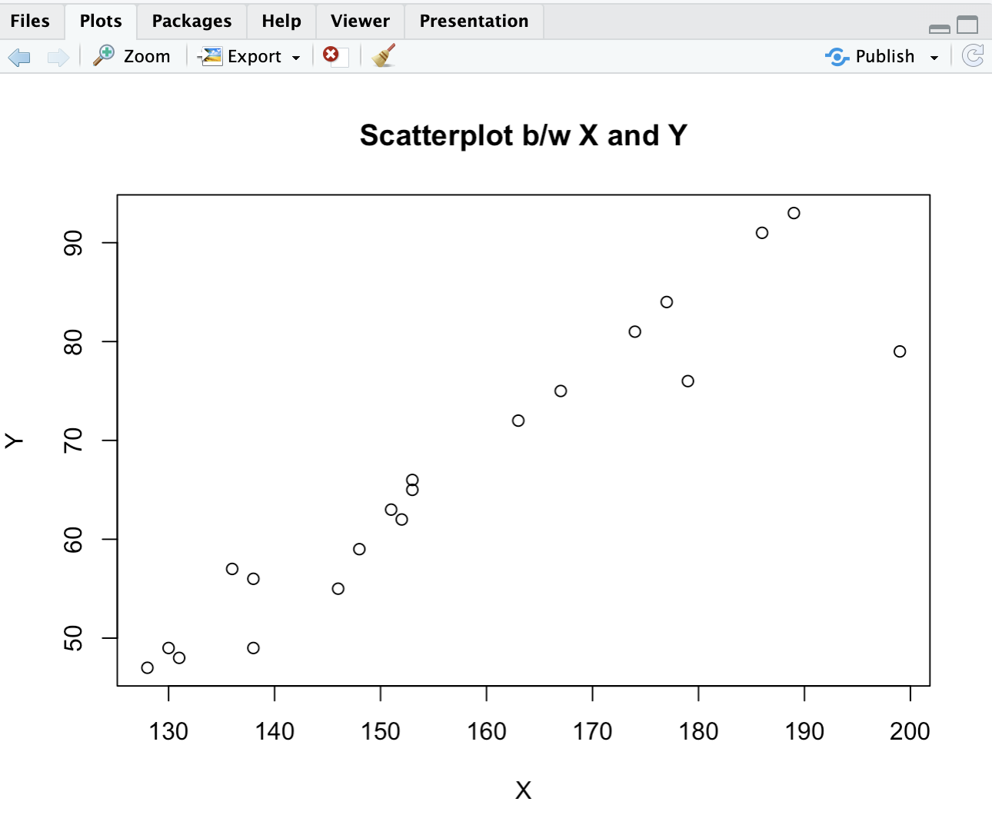
- Simple Linear regression and it’s summary
> simple_reg <- lm(sample_data$Y ~ sample_data$X, data = sample_data)
> summary(simple_reg)

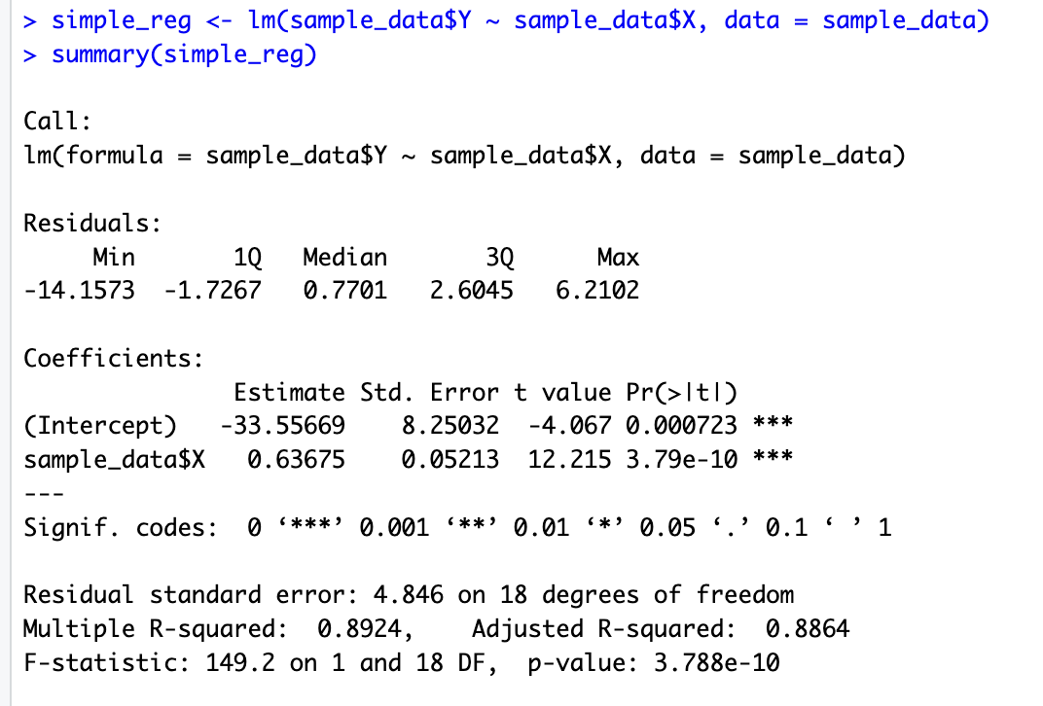

- Intercept
> intercept = simple_reg$coefficients[1]
> intercept

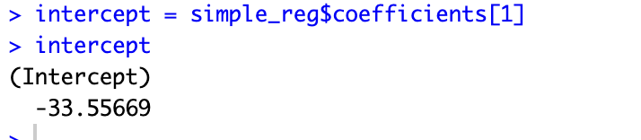

- Slope
> slope <- simple_reg$coefficients[2]
> slope

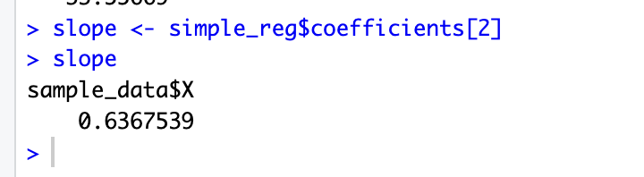

- Linear equation, by putting value of X we can get the value of Y
> X <- 151
> Y <- intercept + slope*X
> Y

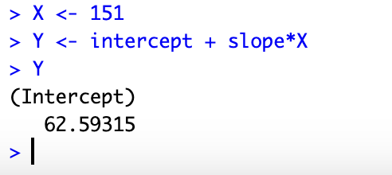

9) Correlation
> cor(sample_data$X, sample_data$Y)
